**JUnit AAA Pattern, Setup & Teardown**

To structure unit tests clearly using the **Arrange-Act-Assert (AAA)** pattern, and manage test lifecycle with @Before and @After annotations

**Tools Used:**

* **IDE**: IntelliJ IDEA
* **Testing Framework**: JUnit 4.13.2
* **Build Tool**: Maven
* **Language**: Java

**1. Arrange-Act-Assert (AAA) Pattern**

A design pattern used in writing readable and maintainable test cases:

| **Phase** | **Purpose** | **Example** |
| --- | --- | --- |
| Arrange | Setup test data or objects | Calculator calc = new Calculator(); |
| Act | Execute the code to be tested | int result = calc.add(2, 3); |
| Assert | Validate the result | assertEquals(5, result); |

**2. Setup and Teardown Methods**

Used to handle test initialization and cleanup automatically.

| **Annotation** | **Purpose** | **Example** |
| --- | --- | --- |
| @Before | Run before each test (setup/fixtures) | calc = new Calculator(); |
| @After | Run after each test (cleanup) | calc = null; |

**Implementation**

**🔹 Calculator.java**

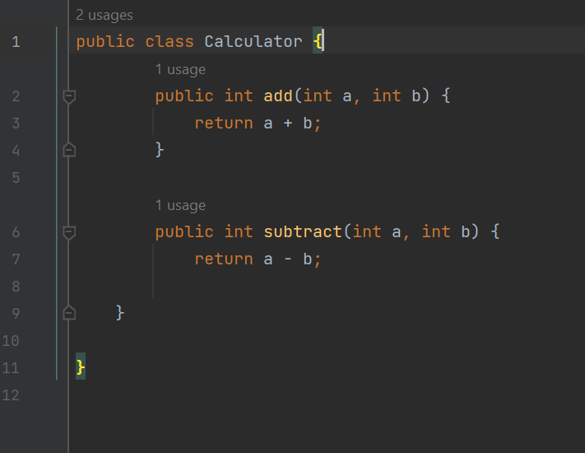

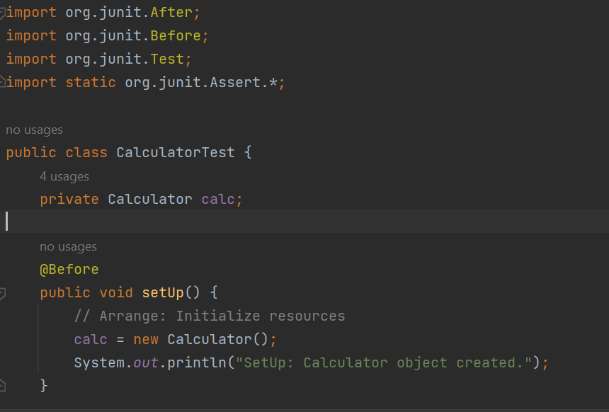**🔹 CalculatorTest.java**

